Intermediate Algebra Lecture 8.2: An Introduction to Non-Linear Functions

Function Notation
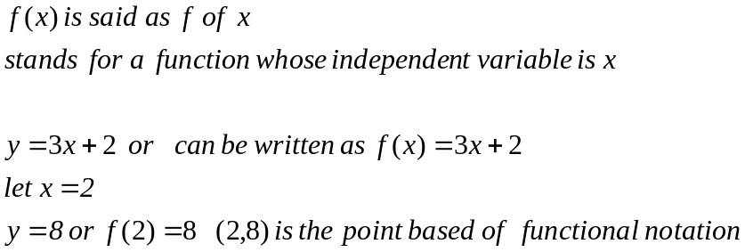

Square Roots
Given a number another number multiplied by itself equals the number.

Example
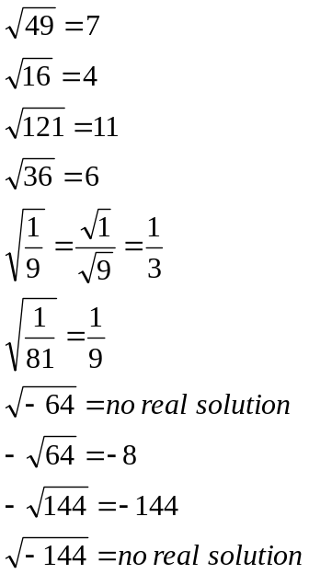

Non-linear graphs
Make a table, use both positive and negative numbers

Example
These graphs demonstrate the direction of the graph by the negative sign in front of the x value. These graphs are reflections of each other

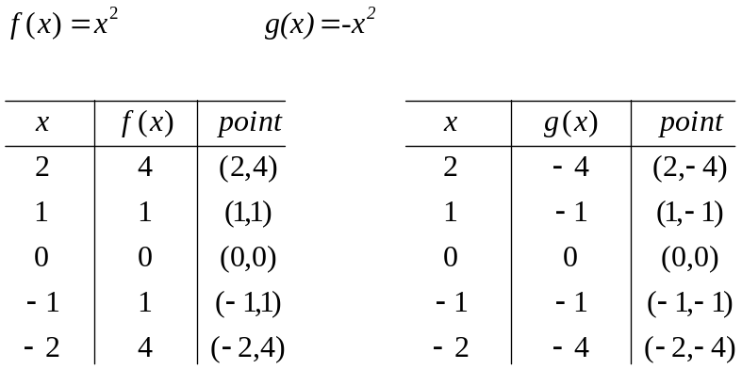

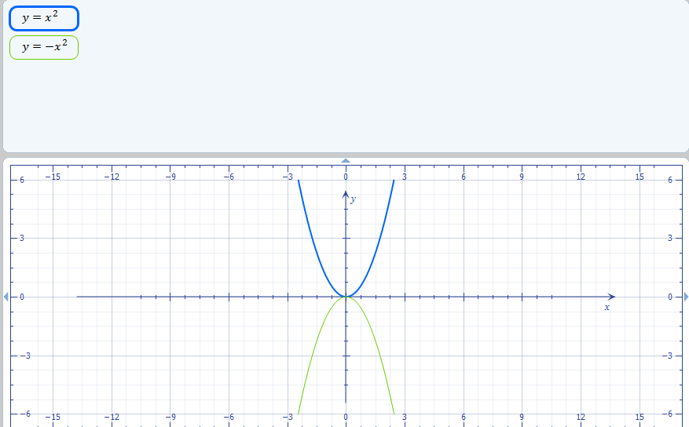

Example
These functions below demonstrate vertical shift of graph by +1

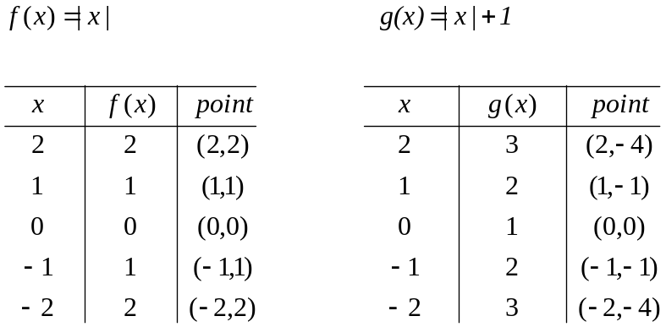

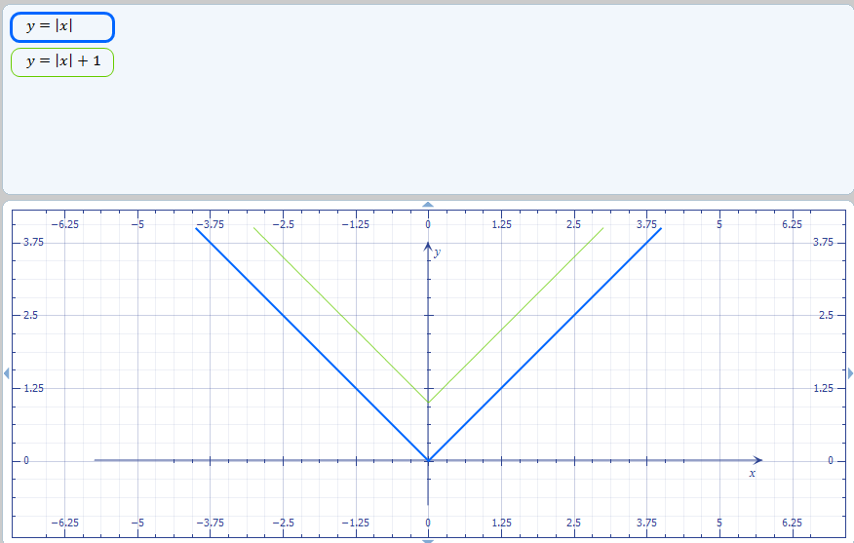

Example
These functions below demonstrate that adding two to x shift to the left by 2
Makes things happen sooner

